Milestone 1: Exploratory Data Analysis in Time Series Data and Portfolio Optimization.

We looked at how stocks have performed over time using charts and graphs. We used these to figure out the best way to invest your money. We wanted to find the right mix of stocks to maximize your earnings while minimizing your risk. We used two special methods, the Efficient Frontier and Robust Optimization, to find the perfect investment strategy.

For example, the investor has Rs. 10,000 then model will suggest in what proportion of money to invest in each stock so that risk is minimum and return is higher. Here this project employed two methods Efficient Frontier method and Robust Optimization Method for optimization of portfolio.

Milestone 2: Data Gathering

Data gathered from official website from Infosys, Sun-Pharma, Tata-Motors, National Stock Exchange, Yahoo- Finance Website.

Milestone 3: Data Preparation and Exploratory Data Analysis

Data has many redundant columns so deleted that column such as open price, volume etc. the data only contains date and closing price for the five companies and for four years. Properly formatted the date column with constant format year-month-date. Removed null value. Converted the object type column format into numeric format for better analysis. Pivoting the table in such as way that the columns are date, Infosys, Sun Pharma, ABFRL, Tata-Motors, Bajaj-Finance.

Created various line chart to understand every company trend line. After inspecting every line charts, it indicates that Bajaj-Finace stock price is highest then all other company stocks and ABFRL is the lowest stock price.

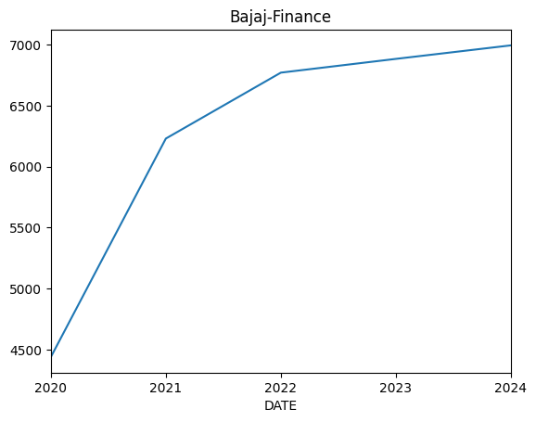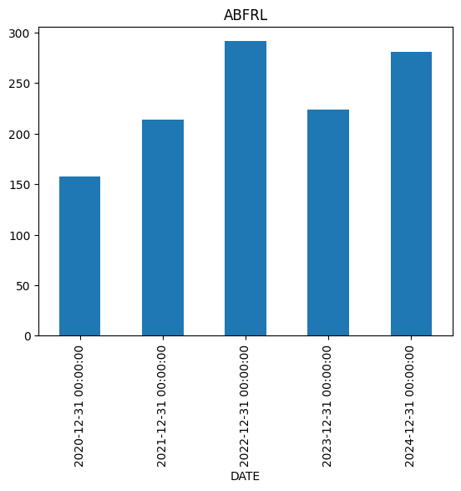

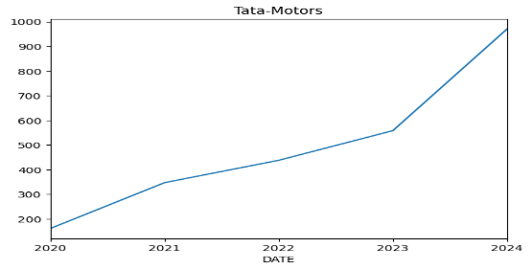 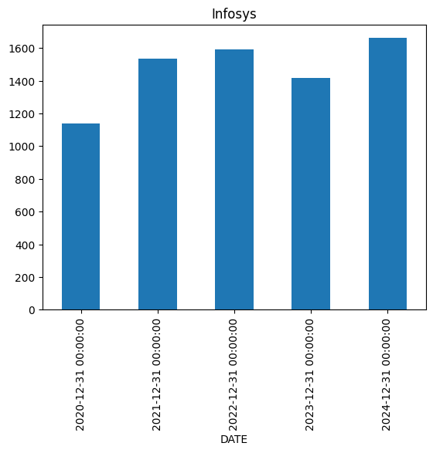

Standard deviation:

Standard deviation measures the fluctuations or volatility means how much a stock's price goes up and down over time, showing its volatility. For each stock in this case (Infosys, Sun Pharma, Tata Motors, ABFRL, Bajaj Finance), the standard deviation tells us how much the stock's price changes compared to its average price. If we compare the standard deviation through diagram then the wider the bandwidth (interval range) more the standard deviation. If we compare the Sun pharma and Infosys diagram then sun pharma standard deviation is wider the Infosys.

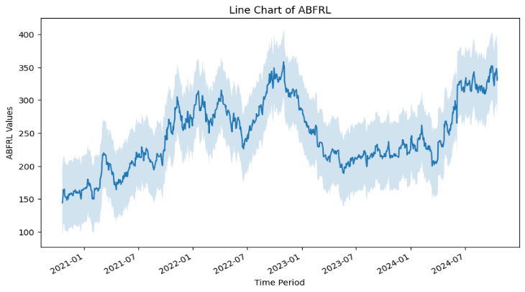 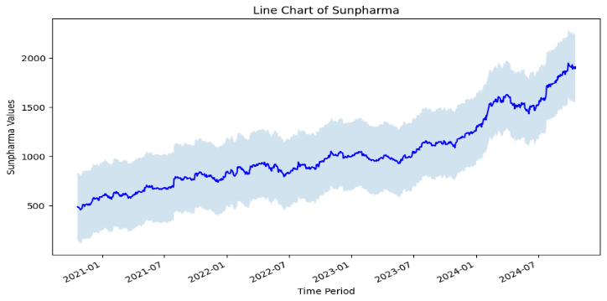 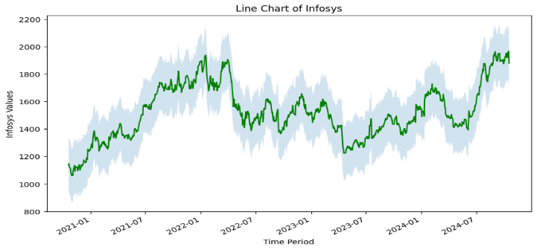

Beta:

Beta is a key metric used to identify an individual stock or portfolios level of volatility against the market standard. It measures the expected increase or decrease of an individual stock price in proportion to movements of the stock price. Beta is the risk-reward measurement that informs investors how sensitive their portfolio is to market changes. Helps investors build and manage their portfolios:

The formula for the beta of an individual stock within a portfolio takes the covariance divided by the variance. Investors can also find the correlation between the market index standard, multiply it by the stocks standard deviation and divide it by the market indexes standard deviation.  
beta=Covariance/Variance  
beta = Cov (rᵢ,rₘ) / Var(rₘ)

Covariance is the measure of a stock’s return as it relates to the market  
Variance is the measure of the market’s return as it relates to the mean  
rᵢ=expected return of the stock  
rₘ = average expected return of the market

beta =1 exactly as volatile as the market

beta >1 more volatile than the market

beta <1 less volatile than the market

beta =0 uncorrelated to the market

beta <0 negatively correlated to the market

ABFRL (-0.0005): The negative beta suggests that ABFRL’s stock moves in the opposite direction to the market. A small value indicates minimal sensitivity to market fluctuations.

Bajaj Finance (-0.0004): The negative beta means Bajaj Finance’s stock tends to move opposite to the market. The very small value again shows that this relationship is weak.

Infosys (-0.0012): With a slightly larger negative beta, Infosys’s stock has an even weaker inverse relationship with the market. This implies that during market downturns, Infosys may perform slightly better, but overall, the relationship is still quite weak.

Sun pharma (0.0002): The positive beta indicates that Sun pharma’s stock has a small positive correlation with the market. It tends to move in the same direction as market changes, but the effect is very weak.

Tata Motors (0.0007): Like Sun pharma, Tata Motors also has a positive beta, indicating it moves in the same direction as the market, but the effect is weak.

ABFRL, Bajaj Finance, and Infosys exhibit weak negative relationships with the market, meaning they tend to move opposite to the market but to a very small extent.

Sun pharma and Tata Motors show weak positive relationships with the market, indicating they tend to move in the same direction as market changes, but again, the effect is minimal.

Based on the provided beta values, Sun pharma and Tata Motors appear to have a slight positive correlation with the market, indicating they might perform better during market uptrends. Tata Motors could benefit from economic recovery or growth in the automotive sector. However, if you’re looking for less market sensitivity, Infosys and ABFRL might be safer bets during market downturns, though their negative betas suggest they won't rise as much in a strong market. If you're aiming for stability with minimal risk to market fluctuations, Infosys could be a good choice.

A beta chart is used in finance to assess a stock's volatility relative to the market. It plots the stock's returns against the market's returns, typically using a scatter plot. The X-axis represents the market returns (e.g., S&P 500), and the Y-axis represents the stock's returns. Each point on the scatter plot corresponds to the returns of the stock and the market during a specific period.

A line plot is then drawn through the scatter points using linear regression, which calculates the slope (beta value). The slope of the line indicates the stock's beta, showing how much the stock moves in relation to the market.

In conclusion, the beta chart helps investors understand the risk profile of a stock relative to the market, aiding in portfolio diversification and risk management.

Milestone 4: Portfolio Optimization

Efficient frontier method for optimization used in first methodology. Initial step we will assume that investor will invest 20% money in each asset (for example investor have 10,000 Rs so for each stock he will invest 200 Rs) then finding Expected Annual return and Annual volatility which is 32% and 20%. Implementing portfolio optimization in this library basically efficient frontier has been implemented. This method will suggest the resource allocation percentage in each asset so that expected return is higher with or slight change in annual volatility. With help of the expected return and annualized sample covariance matrix of assets and Sharpe ratio the result is expected annual return got increased from 20%- 49.2% and annual volatility got slightly increased from 20% to 21.6%. With help of this method, it suggests that to invest 66% of the money in Sun pharma stock and 33% of the money in Tata-Motors.

Second methodology is the Robust Optimization. In this methodology basically returns and covariance

are optimized. It considers a range of possible uncertainty aims to find a portfolio that perform well across all of them. In this methodology maximum expected returns of each company, minimum expected returns of each company, covariance matrix are used. We are calculating each stock expected return (how much you expect to earn) and risk (how much your investment could fluctuate). At the end of the calculation, we will get the optimal weights in simple words the methodology will suggest what percentage of the money to invest in each stock. We are getting suggestion that invest only on Sun pharma company to get higher return.

Mile stone 5: conclusion

In this project, we have done stock market analysis and portfolio optimization. We gathered data from various sources such as from official website of the company, cleaned and prepared it, and then explored the historical performance of five different stocks. We used techniques like line charts and standard deviation to understand their trends and volatility. We also calculated beta to assess their sensitivity to market movements.

To optimize our investment strategy, we implemented two powerful methods: Efficient Frontier and Robust Optimization. These methods helped us find the best possible allocation of funds among the stocks to maximize returns while minimizing risk. The Efficient Frontier suggested a balanced portfolio, while Robust Optimization, considering uncertainty, recommended focusing on Sun Pharma for higher potential returns.

By understanding the historical data and applying these optimization techniques, we can make informed investment decisions and potentially achieve better financial outcomes.

Bibliography:

1. Robust portfolio optimization: a categorized bibliography review by Panos Xidonas
2. Eda on Time series data by Krish Nayak in YouTube
3. Portfolio optimization by efficient frontier by Computer Science (compsci112358) YouTube channel.